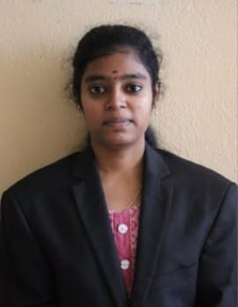
AISWARYA V
+91 7339524234 | aiswarya2504@gmail.com
https://www.linkedin.com/in/aiswarya-v-23586237b
https://github.com/Aiswarya0125

OBJECTIVE
Motivated Artificial Intelligence and Data Science enthusiast with a solid base in machine learning, analytics, and coding. Passionate about developing smart solutions and addressing real-world challenges through data insights. Eager to contribute my technical skills in a progressive organization while continuously learning and growing.
EDUCATIONAL DETAILS
B. Tech Artificial Intelligence & Data Science (2023 – 2027)
VSB College of Engineering Technical Campus (Affiliated with Anna University), Coimbatore CGPA: 8.69
Higher Secondary Certificate (HSC) (2022 – 2023)
Vasavi Vidyalaya Matriculation Higher Secondary School 77%
SKILLS
Programming Languages: Python, Java
Database: SQL
Tools: VS Code, Canva
PROJECTS
Cyber Shield Insight: AI – Powered Cybersecurity Financial Impact & Market Analysis
Developed an AI – powered cybersecurity analytics platform that predicts financial losses and evaluate stock market reactions to cyberattacks. Implemented using Python, Machine Learning and data visualization techniques.
INTERNSHIP
Data Analyst Intern – LITZ Tech
Processed and analyzed large-scale datasets using Python (NumPy, Pandas) to uncover trends and support strategic business decisions. Designed automated reporting dashboards to streamline data tracking and enhance reporting accuracy.
Data Analytics Intern – CODTECH IT Solutions
Build expertise in data analytics, visualization, and reporting by working with real-world datasets. Learned to uncover trends and communicate insights through interactive dashboards and analytical reports.
PUBLICATIONS
Deep Learning-Based Brain Stroke Detection System on CT Images Using CNN Learning – Patent Published (2024)
IN – PLANT TRAINING DETAILS
Signal and Telecommunication Workshop – Southern Railways, Coimbatore
Acquired hands-on exposure to railway signaling and communication system.
Understood the basics of signal maintenance and network operations.
AREA OF INTEREST
Artificial Intelligence & Machine Learning
Cybersecurity
Data analytics
CERTIFICATION
Python Programming: GUVI
Explore Machine Learning Using Python: Infosys Spring Board
Artificial Intelligence: Great Learning
LANGUAGES
Tamil – Native
English – Proficient
DECLARATION
I hereby declaration that all the information provided above is true and correct to the best of my knowledge and belief. I take full responsibility for the accuracy of the details mentioned in this resume.
AISWARYA V

